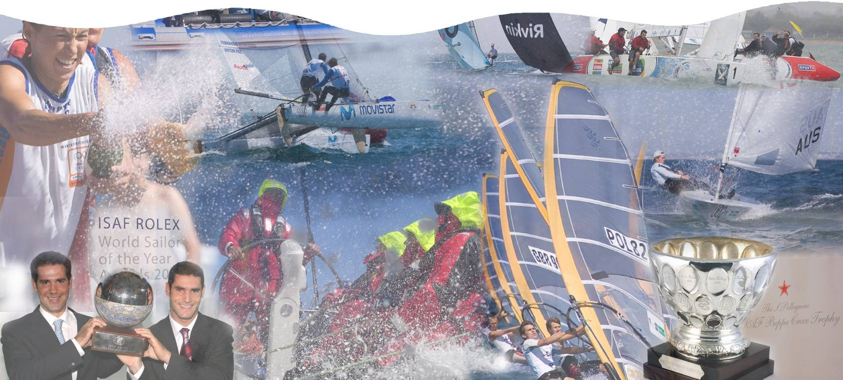

International Sailing Federation

XML Regatta Report Format (XRR)

V1.3.1

Table of Contents

Introduction 1
Purpose 1
Overview 1
Specification 2
Enumerations (basic) 2
Enumerations (ISAF extended) 2
Structure 3

Introduction

Purpose
This document specifies the structure of the XRR data format and describes the elements that are used to represent yacht racing. Including such data as regatta/regatta-series schedules, nations, entries, biographies, courses, results and weather.

The XRR format is required to allow computer systems to exchange sailing related data electronically in a standardised way and to enable up-to-the-minute and accurate reporting of results from central locations.

Overview
The data format detailed in this document defines a very broad and descriptive view of sailing-related information in order to be useful for many purposes and scenarios. The following definitions of the elements and their relations are provided to ensure consistent inclusion of information across all implementations.

Potential applications for the standard are as follows:
- Ability to send results from a client based results package back to a web-hosted database (rather than just sending a flat HTML page)
- Digital availability of regatta and event schedules globally and between organisations on a national basis
- Correlation of centrally hosted information against individual client based applications for regatta management
- Historical availability of regatta, event and individual race results to include course set-ups, mark roundings, weather information and official documents
- Download (and upload) service for sailor biographical information

Specification

Enumerations (basic)

Name | CrewPosition
Description | The position applied to a crew member on board a vessel
Members
  S: Skipper, the person in control over the vessel
  C: Crew, not the person in control over the vessel

Name | EventType
Description | Switch for specifying the purpose of an Event element
Members
  Regatta: Information on an individual regatta
  RegattaSeries: Information on a series of linked regattas

Name | DivisionType
Description | The race-format used for the races in a Divison
Members
  FleetRace: (self explanatory)
  MatchRace: (self explanatory)
  TeamRace: (self explanatory)

Name | MatchRaceEntry
Description | Used to specify the starting position of a boat in a match race
Members
  Port: To port
  Starboard: To starboard

Name | PersonGender
Description | Gender specifier for an individual Person
Members
  Male: (self explanatory)
  Female: (self explanatory)

Name | EventGender
Description | The gender required for the format of an Event or present on a vessel at an Event
Members
  Men: (self explanatory)
  Women: (self explanatory)
  Open: Any combination onboard a boat is acceptable
  Mixed: A boat must have a combination of both genders on-board

Enumerations (ISAF extended)

Name | IFClassCode
Description | An abbreviated name for each class of boat

Name | IFNationCode
Description | 3-letter nation codes as defined by the International Olympic Committee

Name | IFBoatStatus
Description | Also known as “Scoring Abbreviations”, these are for specifying circumstances and rulings applied to the involvement of a boat in a race

Name | IFCfcnGroup
Description | A classification grouping that may be associated with an ISAF member biography/profile

Name | IFCfcnStatus
Description | Textual hint type relating to the existence and validity of an individuals classification

Name | IFRaceStatus
Description | Denotes the position of progression of a race as described

Structure
The following diagram shows the different entities that make up an XRR document with their relations and the fields used to identify them:

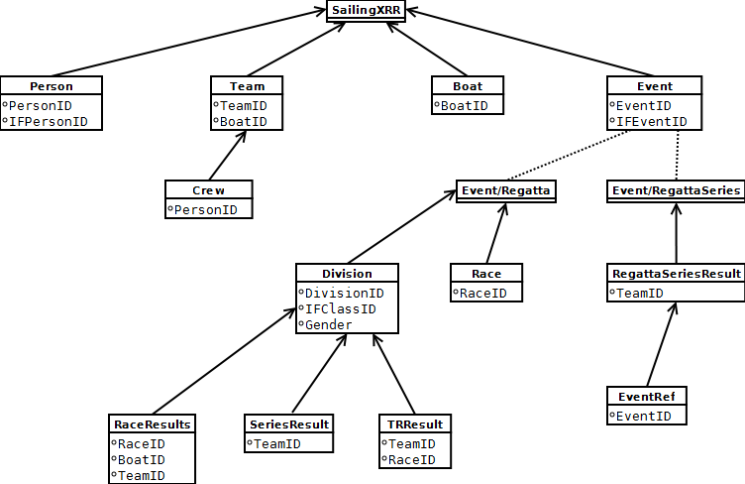

Element Specifications

Element Name | SailingXRR
Element Type | RegattaResults
Description | Used as the root element of an XRR document
Attributes
  Date [date]: The date on which the document was generated
  Time [time]: The time at which the document was generated
  Type [string]: n/a (not currently used for anything – populate with dummy information)
  Version [string]: The version of the XRR schema to validate the document content against
Child Elements | Person, Team, Boat, Event

Element Name | Person
Element Type | Person
Description | Required to represent biography information for an individual included in the document
Attributes
  PersonID [string]: The unique ID of the Person entity/record as recorded in the system on which the document is generated
  IFPersonID [string]: The unique ID used to identify the person according to the International Sailing Federation (ISAF)
  FamilyName [string]: (surname) As recorded in the system on which the document is generated
  GivenName [string]: The name the person is most commonly known by as recorded in the system on which the document is generated
  NOC [IFNationCode]: The code that identifies the nationality of the person as recognised by the International Olympic Committee
  Gender [PersonGender]: The gender of the person in question as recorded in the system on which the document was generated
  ClassificationGroup [IFCfcnGroup]: A classification grouping granted to the Person by ISAF
  ClassificationStatus [IFCfcnStatus]: A status string denoting the presence and validity of the person’s classification
  ClassificationExpiry [date]: The date from which the latest granted classification for the person is no longer valid
Child Elements | n/a

Element Name | Boat
Element Type | Boat
Description | An entity representing a boat included in the document
Attributes
  BoatID [string]: The unique ID for the boat information as recorded in the system on which the document is generated
  BoatName [string]: A name for the boat as recorded in the system on which the document is generated
  SailNumber [string]: A number for the Boat’s sail as recorded in the system on which the document is generated
Child Elements | n/a

Element Name | Team
Element Type | Team
Description | An element representing a group of crew members that is applied to a Boat element, if the Team element is referenced elsewhere in the document then this element must be present.  It is the entity used to associate Person elements with Boat elements.
Attributes
  TeamID [string]: A unique ID for the Team as recorded in the system on which the document is generated
  BoatID [string]: Iternal reference to a Boat element included in the current document
  NOC [IFNationCode]: The code that identifies the nationality of the Team as recognised by the International Olympic Committee
  TeamName [string]: The name given to the team as recorded in the system on which the document is generated
  Gender [EventGender]: Used to identify the presence of a single or set of genders for the Team
Child Elements | Crew

Element Name | Crew
Element Type | Crew
Description | An element that links a Person to a Boat by way of a Team
Attributes
  PersonID [string]: The unique ID used for an internal reference to a Person element
  Position [CrewPosition]: The position the Person is assigned on the Boat on which the Team compete
Child Elements | n/a

Element Name | Event
Element Type | Event
Description | An element that can be used to represent an individual regatta or a series of regattas (such as the World Cup)
Attributes
  EventID [string]: The unique ID for the event as recorded in the system on which the document is generated
  IFEventID [string]: The unique identifier used by ISAF to recognise the Regatta or RegattaSeries
  Type [EventType]: Denotes the element content
  Title [string]: The name of the event as recorded in the system on which the document is generated
Child Elements | (Race, Division) OR (RegattaSeriesResult)

Event-Type: Regatta

Element Name | Race
Element Type | Race
Description | Element representing a Race included in a particular Division
Attributes
  RaceID [string]: Unique ID for the race as recorded in the system on which the document is generated
  RaceNumber [integer]: The number/order in which the race appears as part of a Division
  RaceName [string]: A name to apply to the Race (if one is present) as recorded in the system on which the document is generated
  RaceStartDate [date]: The date on which the race takes place
  RaceStartTime [time]: The time at which the Race takes place
  RaceStatus [IFRaceStatus]: The running state of the Race
  Stage [string]: A stage name associated with the race (e.g. lead-up, final)
  Flight [string]: A flight name associated with the race (if present)
  Match [string]: A match name associated with the race (if present)
Child Elements | n/a

Element Name | Division
Element Type | Division
Description | Element representing a set of races identified by the combination of it’s class, gender and whether or not it is for disabled people’s involvement
Attributes
  Type [DivisionType]: One of the DivisionTypes enumeration
  DivisionID [string]: A unique key used to identify the Division within a regatta as recorded in the system on which the document is generated
  IFDivisionID [string]: A unique ID used by ISAF to identify the division (if known)
  Title [string]: A title string for the set of races
  IFClassID [IFClassCode]: The code used by ISAF to identify the class
  Gender [EventGender]: The gender assigned to the set of races
Child Elements | RaceResults, SeriesResults, TRResults

Element Name | RaceResult
Element Type | RaceResult
Description | Details of the finishing position, points and status for a Team (& Boat) in a Race
Attributes
  RaceID [string]: Internal reference to a unique Race element
  TeamID [string]: Internal reference to a unique Team element
  BoatID [string]: Internal reference to a unique Boat element
  RacePoints[float]: Points allocated to the Boat/Team at the end of the Race
  RaceRank [int]: Final position allocated to the Boat/Team at the end of the Race
  Discard [bool]: Whether this result has been discarded from the overall result
  ScoreCode [IFBoatStatus]: A ruling that has been applied to the Boat/Team
  Entry [MatchRaceEntry]: The starting position of the boat in the case of a match-race
Child Elements | n/a

Element Name | SeriesResult
Element Type | SeriesResult
Description | Overall score for a Boat/Team in a particular Division
Attributes
  TeamID [string]: Internal reference to an individual Team element
  TotalPoints [int]: Overall score for a Team/Boat accumulated for all Races in the Division before applying any overall calculations
  NetPoints [int]: Overall score for a Team/Boat accumulated for all Races in the Division with overall calculations applied
  Tied [bool]: Specifies that the overall result is a tie with another Team/Boat
  Rank [int]: Overall finishing position applied to the Team/Boat for the Division
Child Elements | n/a

Element Name | TRResult
Element Type | TRResult
Description
Attributes
Child Elements

Event-Type: RegattaSeries

Element Name | RegattaSeriesResult
Element Type | RegattaSeriesResult
Description | Used for reporting the overall scores for teams across a number of linked regattas
Attributes
  TeamID [string]: Unique internal reference to a Team element as recorded in the system on which the document is generated
  TotalPoints [string]: Overall points for the Team – sum of final results from all regattas
  Rank [string]: Overall finishing position for the Team
Child Elements | EventID

Element Name | EventID
Element Type | EventRef
Description | A unique ID for a regatta included in the series as recorded in the system on which the document is generated
Attributes
  Value [string]: The unique ID
Child Elements | n/a

Element Name
Element Type
Description
Attributes
Child Elements

